**Community Health**

**Needs Assessment**

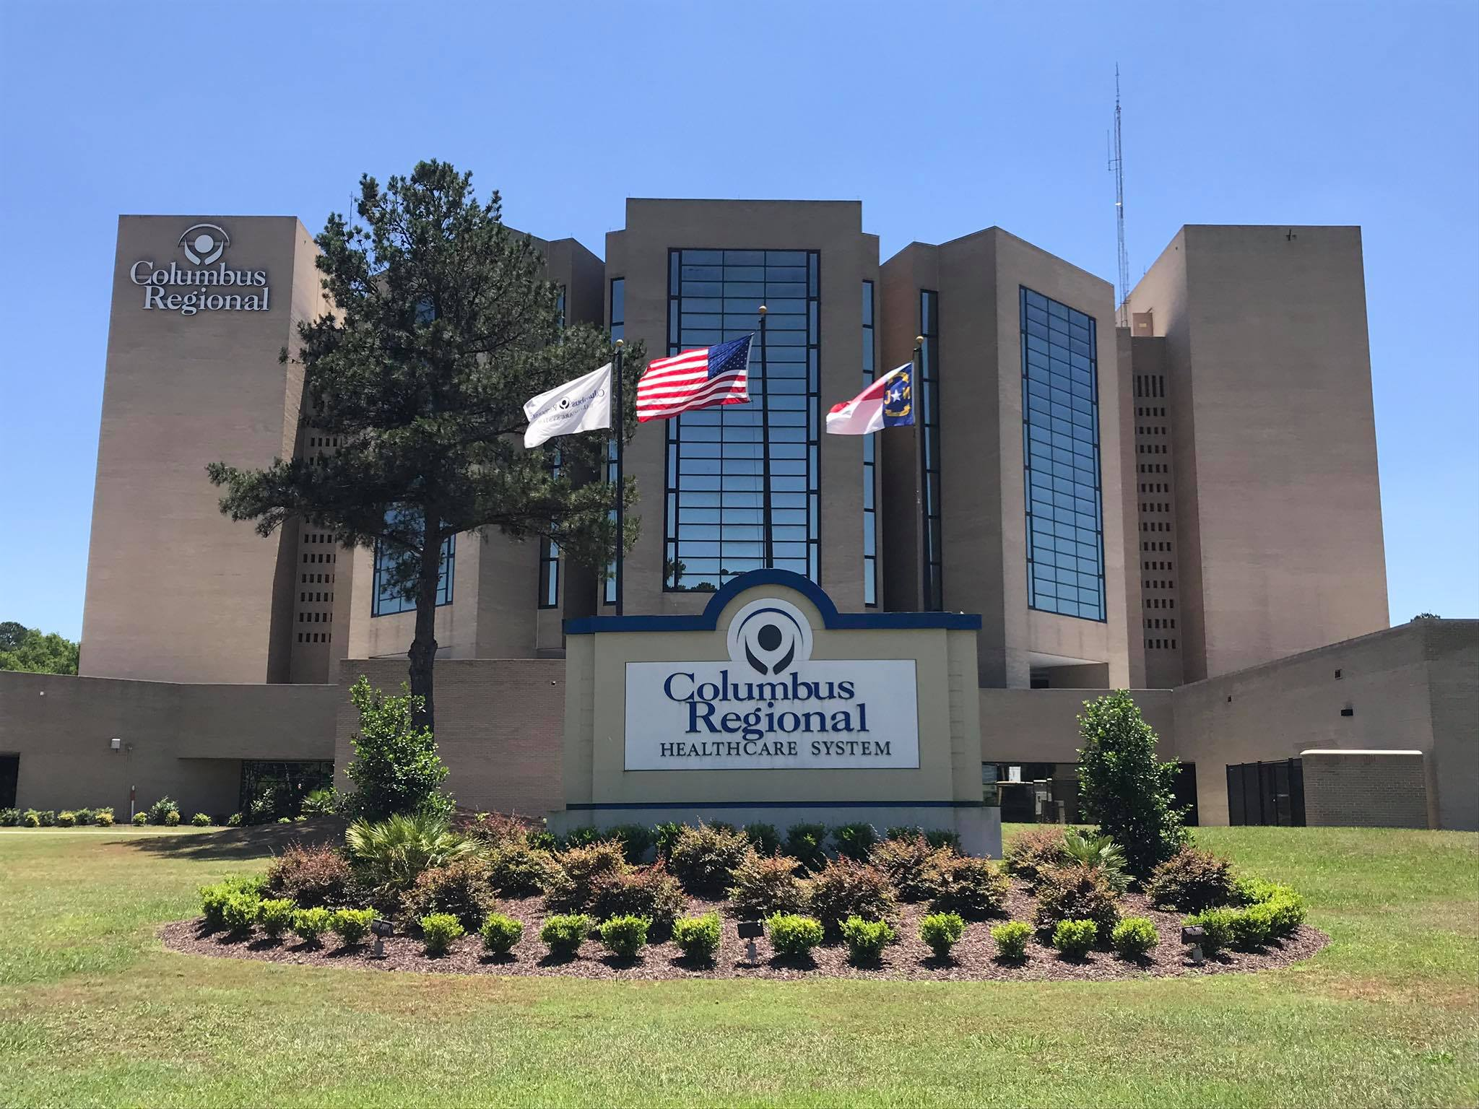

500 Jefferson Street

Whiteville, NC 28474

910-642-8011

October 1, 2025

# Table of Contents

I Executive Summary

a. Summary of Findings

b. Identified Health Priorities

1. About Research

1. Community Served – Columbus County

1. General State of Our Community’s Health
   1. Summary of Findings
   2. County Health Rankings
   3. Healthy Lifestyles and Behaviors
   4. Health Environment
   5. Health Risk Factors
   6. Health Outcomes – Morbidity & Mortality
   7. Health Services – Preventive Clinical and Access

1. Community Feedback – Community Health Survey

1. Identified Priority Health Needs & Related Assets

1. Implementation Strategies
2. Surveys – English and Spanish

1. Appendix
   1. Map of Columbus Regional Healthcare System
   2. Map of Columbus County
   3. CHNA Team
   4. Columbus County Resources

# Executive Summary

## **Background and Purpose**

Columbus Regional Healthcare System, located in Columbus County, North Carolina, is the leading healthcare provider serving the health care needs of those in the Columbus County area. With a mission *to be the primary healthcare home of the citizens of Columbus County and surrounding communities,* Columbus Regional Healthcare System is dedicated to improving the health of the community and being a leader in raising standards for excellence in care delivery of care.

In the spring of 2022, Columbus Regional Healthcare System staff in collaboration with stakeholders in Columbus County convened a Wellness Initiative to review obstacles to health and physical needs of residents in our county. These efforts focused on assessing community health needs, local health resources, barriers to care, gaps in services, and trends regarding health and healthy lifestyles and seeking funds to address strategies developed during this process. The strategies developed during this process played a significant role in the development of the 2022 CHNA and catapulted the community and hospital to continue to encourage the continuation of healthy habits and activities for residents of Columbus County through 2025.

Members of the collaboration continued to meet during 2023 and scored the following rewards for the county:

* Worked with the Kate B. Reynolds Foundation to obtain funding to complete the construction of the first inclusive playground located across from The Department of Social Services in Whiteville, North Carolina. The facility is well-lit for late evening use, with shelters for picnics and bathrooms. It is well utilized.
* CRHS obtained a grant from Kate B Reynolds to and contracted with a consulting firm in Chapel Hill to work with our county to develop our Opioid Assessment Plan which led to funding for several projects, some of which began operation in 2024.
* The approval of the Opioid Assessment Plan has allowed the county to begin the operation of a county Drug Court where drug offenders are provided the opportunity to be seen in this type of setting rather than Criminal Court. They are assigned a Case Manager and supervised throughout their treatment and remainder of sentence.
* The grant also included a contract with the Healing Place in Wilmington for eighteen beds for residents of Columbus to undergo drug rehabilitation. Eighteen residents from Columbus County were eligible for immediate placement.

Data Collection and Process.

The 2025 CHNA was incorporated into a Survey Monkey and pen, and paper surveys were prepared in both English and Spanish. A listing of possible agencies that should be included in the dissemination of surveys was developed. These sites include, but not limited to:

* Columbus Regional Healthcare Staff
* Columbus County and Whiteville City Schools
* Southeastern Community College Faculty, Staff and Students
* Physician Offices
* Behavioral Health Centers
* Hispanic Outreach Programs
* Columbus Baptist Fellowship
* Columbus Ministerial Association through CRHS Chaplain’s Office
* Waccamaw Siouan Development Office
* All Law Enforcement Agencies
* Columbus County Government
* Local Town and City Governments
* Faith Based organizations.
* Columbus County Chamber and Tourism
* Private medical practices and clinics

Our intent was to distribute surveys throughout the county and utilize those listed above to obtain responses that reflect the entire community. Whiteville, being the largest township in the county, was expected to have the greatest return and reflected in our response rate. An effort was made to reach what the group considered to be underserved areas of the county and members of the committee were asked to reach out to individuals in these areas.

The Community Health Needs Assessment (CHNA) Survey developed for this assessment cycle.

<https://www.surveymonkey.com/r/RKWS9LJ>

Key findings through the CHNA, as they did is 2022, indicate residents note a lack of access to health care and the funds to pay for medical services, chronic diseases (heart disease, stroke, cancer and diabetes), premature deaths due to accidents, suicides and drug abuse, issues with obesity and impact on individuals dealing with weight management, illegal drug and prescription drug abuse, safe places for recreation and exercise and lack of facilities for this purpose. This assessment identified similar issues surrounding nutrition, weight management, exercise, and safe recreational spaces for the entire family. The full CHNA assessment tool including questions and comments by respondents is included in the pdf file included in the Appendix.

**Identified Health Priorities**

A variety of data and information has been collected and analyzed used to identify key priority health needs of the community. The prioritization process included review and analysis of:

1. Secondary, quantitative statistical data,
2. Primary, qualitative community feedback, and
3. Current community and Columbus Regional Healthcare System assets.

We have continued to work in concert with the Columbus County Substance Abuse/Misuse Coalition to identify priorities and discuss potential action plans. To select priorities and related strategies, the following criteria have been considered:

* Data and community feedback indicated the issue as an important need in the community.
* Columbus Regional Healthcare System has the capacity to address needs.
* Addressing a selected issue holds the potential to affect other key health conditions, therefore creating a multiplying effect.
* Strategies selected align with and support Columbus Regional’s mission and strategic direction.
* Strategies selected take into consideration current assents in both the community and within Columbus Regional Healthcare System

In considering the above, the following priorities were selected:

#### 1. Heart Disease and Stroke

As noted in the previous Community Health Needs Assessment, residents indicated heart disease is the number one leading cause of death in Columbus County attributing to 209 deaths or 27.9% in Columbus County while cerebrovascular occurrence is approximately 1% lower than the state average (NCSCHS, 2017). Respondents on the county survey indicated Stoke and Cerebrovascular Disease was the third highest cause of death but according to statewide data, Columbus County ranks fourth in cause of death with the same ranking as the statewide statistics. (NCSHS, 2017). While high blood pressure, smoking and physical inactivity are considered four major risk factors, other factors such as obesity and diabetes are also considered as risk factors.

#### 2. Cancer

Cancer was identified by residents as the second highest cause of death in Columbus County with 23.19% responding to this question. The N.C. Division of Public Health reports cancer as the second highest cause of death in Columbus County at 17.8% and 133 deaths. These statistics are from the NCSCHS 2017 Leading Causes of Death in Columbus County statistics. Cancer continues to be the leading cause of death in North Carolina with a percentage of 20.9&% of the 19,474 deaths. Breast Cancer was the leading cause of death with 296 followed by Lung cancer with 253. Total deaths due to cancer were the leading cause of cancer deaths in Columbus County in 1764.

#### 3. Diabetes

The prevalence of diabetes continues to be high in Columbus County and is tied with cerebrovascular disease for the fourth leading cause of death (NCSHSC, 2017). Diabetes is also a major cause of death and disability in North Carolina and across the nation. With a greater prevalence of obesity and an increasing elderly population, diabetes is approaching epidemic proportions in North Carolina. Diabetes deaths are higher among African American males with a rate of 55.2% compared to White males with a rate of 26.1%. (Columbus County 2019 Health Data Book).

[Columbus County - NCIOM](https://nciom.org/counties/columbus-county/)

Our response rate was lower for this assessment with a total of 295. Columbus County residents had the highest response rate of 83.05. We must work hard to increase response rates for the CHNA and increase awareness in the community during this cycle. Respondents in our survey indicated the highest chronic conditions they have been told by a doctor, nurse of health provider is asthma, diabetes, high blood pressure and high cholesterol all of which are related to cardiovascular disease. The responses relate to the 2025 Health Rankings which placed Columbus County 94 out of 100 in health outcomes and 92 out of 100 in health factors which will be covered in later portions of this document.

When asked about the biggest health concern or issue in the community, respondents indicated illegal drug use and low income /poverty and violent crime ranked highest among their concerns. This response correlates with data included in the County Health Rankings and Roadmaps 2002 rankings for Columbus County. This data indicated higher than state average for drug overdoses in Columbus County in addition to higher numbers of violent crimes which could be attributed to illegal drug use by residents; one reason the county was funded by The Kate B. Reynold Foundation to conduct a needs assessment on opioid/ substance abuse misuse. Our county rates are higher than the state average in motor vehicle deaths, lack of mental health, primary care providers and dentists. We are designated as medically underserved and recognized as a food desert by USDA. Agencies throughout the county, including the Columbus County Farmers Market are working together to address the poor nutritional habits of our residents.

MUA_Find_Export (2).pdf

[HPSA Find (hrsa.gov)](https://data.hrsa.gov/tools/shortage-area/hpsa-find)

* Community assets related to these needs have been identified in the *Identified Priority Health Needs &* *Related Assets* section of this report.
* Strategic initiatives to address each of these identified needs are being developed and are included in the Columbus Regional Healthcare System’s Community Health Needs Assessment- Implementation Strategies and is reported annually to the IRS on Form 990.
* The 2025 CHNA report will be made available to the public and posted on Columbus Regional Healthcare System’s website: [www.crhealthcare.org](http://www.crhealthcare.org/)

**About Research**

Community research was conducted by a Community Wellness Committee comprised of members the various communities, key stakeholders from Columbus Regional Healthcare System, Columbus County Health Department, various local businesses public and private non-profits, public officials, private citizens faith-based organizations. A community-based approach was taken to complete the community health needs assessment. National, state, regional and county specific data were collected from a broad set of data sources. Special emphasis was placed on assessing The Healthy People 2030 Leading Indicators, the North Carolina Data Portal and data obtained from the North Carolina medically underserved areas and gathering information from community residents, providers of health and human services and other stakeholders and representatives of Columbus County. The Healthy People 2030 have four overarching goals:

* Attain high-quality, longer lives free of preventable disease, disability, injury, and premature death.
* Achieve health equity, eliminate disparities, and improve the health of all groups.
* Create social and physical environments that promote good health for all; and
* Promote quality of life, healthy development, and healthy behaviors across all life stages.

For access to the archived slides from HP2030 Progress Reviews, see:

[Healthy People 2030 | odphp.health.gov](https://odphp.health.gov/healthypeople)

Efforts were made to ensure that the research was conducted in a manner that was representative of the communities within Columbus Regional’s primary service area. The primary service area and focus of the CHNA is Columbus County as 23,511 patients were from Columbus County. This includes inpatient, outpatient and emergency room discharges.

Research methods were conducted in an approach that incorporated both quantifiable and qualitative data to get a well-rounded view of the state of the community’s health needs.

1. Collection of **statistical (secondary, quantitative) date** at national, state, regional and local levels-key data sources included Healthy People 2020, County Health Rankings, National Health Indicators Warehouse, CDC and North Carolina DEHEC biostatistics and hospital discharge data. Dates of data collected ranged from 2013-2022. For each indicator, data was pulled for the most recent year available. In addition, data was pulled when available from previous years in order to assess progress.
2. Collection of **qualitative data** through a community health assessment survey was distributed throughout Columbus County via web link, survey monkey, email and pen and paper hard copies in English and Spanish in addition to personal visits and presentations across the county.

**Community Served – Columbus County**

The primary service area and focus of the CHNA is Columbus County as 23,511 patients were from Columbus County. This includes inpatient, outpatient and emergency room discharges.

**Population Growth**

Columbus County, North Carolina’s estimated population of 50,453. Columbus County, North Carolina is the 53rdt largest county in North Carolina. The county decreased in population from 56,279 in 2016. Resident who are cost-burdened when attempting to purchase a house total 30% or 5,303 homes which is greater than the state percentages. Renters comprise 49% of the population and 25% have difficulty affording their homes. Columbus County ranks #51 in eviction rates and 63 families have faced foreclosure this year. Families who have faced an eviction filing this year total 305.  
[NCH-CountyProfile-Columbus.pdf](https://nchousing.org/wp-content/uploads/2017/01/NCH-CountyProfile-Columbus.pdf)

## [County-Data-Fact-Sheet-2024-FULL.pdf](https://www.ncacc.org/wp-content/uploads/2025/08/County-Data-Fact-Sheet-2024-FULL.pdf)

:

**Race Population**

White Alone 60.16%

Black or African American 28.68%

American Indian/Alaskan 3.10%

White Alone, Not Hispanic or Latino 58.7%

Two or More Races 4,54%

Asian 0.42%

Latino/Hispanic 5.2%

Native Hawaiian or Pacific Islander 0.1%

Some other Race 3.05%

[Columbus County, NC Population by Race & Ethnicity - 2025 Update | Neilsberg](https://www.neilsberg.com/insights/columbus-county-nc-population-by-race/)

**POPULATION**

***Total*** 54,575 **Annual Growth Rate** -0.57

Fair Bluff 728

Tabor City 3,831

Whiteville 5,434

Sandyfield 439

Clarendon 1,407

Boardman 161

Brunswick 313

Cerro Gordo 143

Delco 2,090

Lake Waccamaw 1,227

Bolton 383

Riegelwood 3,750

Chadbourn 1,528

Evergreen 1,651

Hallsboro 1,432

[Incorporated Places in Columbus (North Carolina, USA) - Population Statistics, Charts, Map, Location, Weather and Web Information](https://www.citypopulation.de/en/usa/northcarolina/37047__columbus/)

Patients treated in 2024 at Columbus Regional Healthcare System represented by the following zip codes.

|  |  |
| --- | --- |
|  |  |
| **Columbus County Zip** | **Count** |
| 28320 | 2 |
| 28357 | 1 |
| 28423 | 662 |
| 28424 | 99 |
| 28430 | 873 |
| 28431 | 3,771 |
| 28432 | 867 |
| 28433 | 14 |
| 28436 | 216 |
| 28438 | 756 |
| 28439 | 677 |
| 28442 | 834 |
| 28450 | 1,087 |
| 28455 | 708 |
| 28456 | 329 |
| 28463 | 2,438 |
| 28472 | 10,177 |
|  | 23,511 |

## **Education**

Columbus County is below the state average for high school graduates at 86.3% which is less than the state rate of 87.6%. Unemployment as of August 2025 is 4.3%. All these, combined with number of children living in poverty, and low median household income contribute to low educational attainment and less than a well-trained workforce. (County Health Rankings and Roadmap, 2025) The student population of our County is skewed towards women with 427 male students and 844 female students receiving degrees 326 degrees from universities or colleges. Most graduates are White followed by Black or African American and most common majors are Liberal Arts and Sciences, General Business Administration and Management and Electrical Engineering and Technology. Graduation rate is 84.4% compared to 88% at the state level. Rates in Columbus County vary from the very high 90percent to a rate of 62% or lower.

[Educational Achievement in Columbus County, NC | BestNeighborhood.org](https://bestneighborhood.org/educational-achievement-in-columbus-county-nc/)

**Income and Poverty**

|  |
| --- |
|  |

The economy of Columbus County, NC employs 20.5k people. The most common jobs held in Columbus County, NC are Sales and Related occupations (2,155 people), Production Opportunities (1804 people) Office and Administrative Support Occupations (1686 people). Compared to other counties, Columbus County, NC has an unusually high number of residents working as Law Enforcement Workers including Supervisors (1.89 times higher than expected). Health Technologies and Technicians 1.83 times) and Farming, Fishing and Forestry Occupations (1.8 times.)

The highest paid jobs held by residents of Columbus County, NC by median income are Architecture and Engineering Occupations ($61,250), Health Diagnosing & Treatment Practitioners and other Technical occupations ($57,188), Life, Physical and Social Science Occupations ($56,250).The highest paying job in Columbus County, NC by median earnings are Utilities ($53828), Transportation and Warehousing and Wholesale Trade ($48,931).

Median household income totaled $73,958 in North Carolina in 2024, compared to [**median income of $83,730**](https://www.census.gov/newsroom/press-releases/2025/income-poverty-health-insurance-coverage.html) for the nation as a whole, according to numbers released Sept. 9 by the United States Census Bureau. Median household income in Columbus County for 2023 was $48,184 which was 31% less that figures statewide. Persons living below the poverty line stands at 18.8% of the population, which is 1.4 times the amount in North Carolina. Senior citizens above the age of 65 total 13 % of the population living in poverty. Per capital income is $26,775, about two-thirds of the amount in North Carolina. Children in poverty are 29% and rank 87th in the state. Seventeen percent experience food insecurity. Fifteen percent under age 65 are uninsured. Twenty-three residents died of drug overdoses and 74 visited ED for drug overdose in 2024.

[NC median household income reaches $74K in 2024, according to Census](https://www.carolinajournal.com/nc-median-household-income-reaches-74k-in-2024-according-to-census/)

[2025_02_Median_HHI.pdf](https://www.ncacc.org/wp-content/uploads/2025/01/2025_02_Median_HHI.pdf)

[Columbus County, NC - Profile data - Census Reporter](https://censusreporter.org/profiles/05000US37047-columbus-county-nc/)

<https://datausa.io/profile/geo/columbus-county-nc/#economy>

<https://www.countyhealthrankings.org/app/north-carolina/2019/measure/factors/63/data>

[Columbus County, North Carolina | County Health Rankings & Roadmaps](https://www.countyhealthrankings.org/app/north-carolina/2022/rankings/columbus/county/outcomes/overall/snapshot)

[Compare Counties in North Carolina - Columbus (CU) | County Health Rankings & Roadmaps](https://www.countyhealthrankings.org/app/north-carolina/2022/compare/snapshot?counties=37_047)

[Columbus County, North Carolina | County Health Rankings & Roadmaps](https://www.countyhealthrankings.org/app/north-carolina/2022/rankings/columbus/county/outcomes/overall/snapshot)

[County-Data-Fact-Sheet-2024-FULL.pdf](https://www.ncacc.org/wp-content/uploads/2025/08/County-Data-Fact-Sheet-2024-FULL.pdf)

**Unemployment**

According to the Columbus County Health Rankings and Roadmaps, 2025, unemployment in Columbus County is 4.0%. According to the Bureau of Labor Statistics, unemployment in NC as of 2025 is 3.5%

<https://accessnc.nccommerce.com/DemoGraphicsReports/pdfs/countyProfile/NC/37047.pdf>

<https://www.bls.gov/eag/eag.nc.htm>

With the downturn in the economy over the past several years, poverty rates have climbed at an alarming rate and are much higher than the nation’s 14.3% poverty rate. Columbus County’s poverty rate has increased to 23.3% when compared to the state’s poverty level of 16.1%.

# **General State of our Community’s Health**

For a general overview of the state of health outcomes and related factors please refer to the following report.

[Columbus County | Healthy Communities NC](https://healthycommunitiesnc.org/profile/geo/columbus-county)

# **Summary of Findings**

## General Social Characteristics

* Columbus County’s population has experienced a decline since 2011. Population statistics now indicate a total of 54,575, a decline of 311.
* Educational attainment stands at 6.33% below ninth grade, and 33% no higher than a high school education The highest graduation rates are among the Asian population with a rate of 100%.
* Columbus County continues to reflect a more diverse population than the state and nation with more females than males, a difference between 39.9% and 43.7%. Of our 44,150 adults, 10,484 are considered senior citizens.
* Median household income has remained stagnant over the past 10 years and is lower than the state and nation. Poverty rates have increased at an alarming rate and is now 23.62% and higher among females. The average wage earned in Columbus county is $29,739.
* Unemployment remains higher than the state and national average.
* Spanish is the only language spoken by 4.69% of the population.

## General Health Rankings

* Columbus County was ranked as the least healthy county in the state of North Carolina for the years 2009 – 2014 ranking 100 out of 100. In 2025 some improvement to the overall rank was achieved with a score of 96 out of 100. The health outcomes ratings (morbidity, mortality) were 96 among the health factors ratings (social, economic, environment, health behavior factors). Health rankings released for 2025 showed Columbus County ranked 91st in the state in Health outcomes and 92nd in Health Factors

[North Carolina | County Health Rankings & Roadmaps](https://www.countyhealthrankings.org/health-data/north-carolina?year=2025)

## Healthy Lifestyles

* Overweight and obese adults and children are a concern, as well as habits related to lack of exercise and healthy eating.
* Community Perceptions: Feedback from the community health assessment surveys indicated that there is still a lack of physical activity, eating healthier foods and smoking among adults as reported in the 2015 Behavioral Risk Factor Surveillance Survey (BRFSS). These three health behaviors are self-reported among Columbus residents and negatively impact the health of residents.
* Most people have a general knowledge of how lifestyle choices impact health; however, most do report that for reasons related to cost, access and convenience it is difficult to maintain a healthy lifestyle. Survey respondents stated the economy is their biggest concern and they feel the lack of job opportunities and insufficient funds to pay for everyday necessities are two main reasons our county continues to be ranked low in the state for health factors and outcomes.

Health Risk Factors

* Prevalence of diabetes continues to be at a high rate and Columbus County has a higher rate than both the state and nationally.
* Infant mortality and preterm births are higher than the state average in addition to 43 compared to 27 at the state level.
* Columbus County in the 2025 Health Rankings and Roadmaps indicated Columbus County had 16500 premature age-related mortality as compared to 9400 at the state level with less than the state average life expectancy of 74.

[Columbus, North Carolina | County Health Rankings & Roadmaps](https://www.countyhealthrankings.org/health-data/north-carolina/columbus?year=2025)

* Community Perceptions. The community health assessment surveys consistently reported that obesity, chronic disease and drug/alcohol abuse were the number one health problems in Columbus County.

## Health Outcomes- Morbidity and Mortality

* Diseases of the heart were the number one leading cause of death in Columbus County in 2017 attributing to 209 deaths.
* Cancer is the second leading cause of death in adults in Columbus County in 2017 attributing to 133 deaths.

## Mental Health

* Columbus is now served by Trillium (LME). There are several private providers (for-profit and non-profit) endorsed by them to provide at least one service related to mental health, developmental disabilities, and substance abuse including Bridgepoint and Advanced Behavioral Services in addition to on-going classes for those who have been referred by the local courts.
* Feedback from the community indicates that there is a growing concern regarding mental health services related to substance abuse including prescription and illegal drug use. Of the 28,710 patients receiving services in the ED during 2018, 265 were referred for mental health services.

Health Services

* Due to the lower-income status of Columbus County, it is designated as a medically indigent with a Health Professional Shortage Area (HPSA) Score of 19 in primary care. In 2025, Columbus County had a ratio of 1 primary care provide to 2,500 residents as compared to 1 to 1410 residents in the state.
* Columbus County has improved and fares comparable to the state and nation in preventive clinical services such as diabetes screenings, but mammography screenings are lower than the state average of 41%. Our CHNA indicated most females responding having had a mammogram within the last twelve months.
* With increases in unemployment in Columbus County, the community reports that access to care remains an issue, due mostly to lack of insurance and inability to pay for medical co-pays and prescriptions. For an overall overview of Columbus County please visit the following website published by US News and World Report.

Columbus County, North Carolina is Rural. In Columbus County, 89.7% of the population lives in a low population density area. The health of a place results from past and present policies and practices. The land known as Columbus County, along with its entirety of the U.S. has been home for many thousands of years to hundreds of Indigenous nations, Native Land Digital “strives to create and foster conversations about history of colonialism, Indigenous ways of knowing, and settler-Indigenous relations. Columbus County, North Carolina is Rural. In Columbus County, 89.7% of the population lives in a low population densityarea.

[How Healthy Is Columbus County, North Carolina? | US News Healthiest Communities](https://www.usnews.com/news/healthiest-communities/north-carolina/columbus-county)

**Perceptions from the Community Health Assessment Surveys included:**

Issues with access to care

* Lack of insurance,
* Appointments are not available when needed.
* Transportation
* The community reported an increase in job opportunities would improve the health of

their families, neighbors and friends while decreasing barriers to health care.

* The community reported additional need for health screenings and assistance for individuals with mental health needs and resources to combat illegal drug use and abuse of prescription drugs.
* Lack of specialists and increase in health providers.
* Drug and alcohol prevention opportunities in addition to mental health providers.

## Children’s Health

Obesity is a condition affecting many residents in Columbus County and is the number one health problem in children. In North Carolina in 2014, 15% of children, ages 2-4, receiving WIC services, were considered obese. In 2017, 13.1% percent of children aged 10-17 were considered obese and 15.4% of high school students were obese. North Carolina ranks 19th in the nation for the number of individuals diagnosed as obese. More children eligible for free lunch, lack of exercise and lack of choices for health foods contribute to this health issue. Asthma discharges from hospitals in Columbus County have decreased in the last four years.

[North Carolina Data Portal](https://ncdataportal.org/)

**COUNTY HEALTH RANKINGS**

The *County Health Rankings* rank the health of nearly every county in the nation and shows that much of what affects health occurs outside of the doctor’s office. Published by the University of Wisconsin Population Health Institute and the Robert Wood Johnson Foundation, the *Rankings* help counties understand what influences how healthy residents are and how long they will live. The *Rankings* confirm the critical role that factors such as education, jobs, income, and environment play in influencing health. The Rankings look at a variety of measures that affect health such as the rate of people dying before age 75, high school graduation rates, access to healthier foods, air pollution levels, income, and rates of smoking, obesity and teen births. The *Rankings*, based on the latest data publicly available for each county, are unique in their ability to measure the overall health of each county in all 50 states on the multiple factors that influence health. Visit the websites listed below to view the full document. Also included is the data for years of life lost based on life expectancy by total and sex.

[North Carolina | County Health Rankings & Roadmaps](https://www.countyhealthrankings.org/health-data/north-carolina?year=2025)

[North Carolina Downloads | County Health Rankings & Roadmaps](https://www.countyhealthrankings.org/app/north-carolina/2020/downloads)

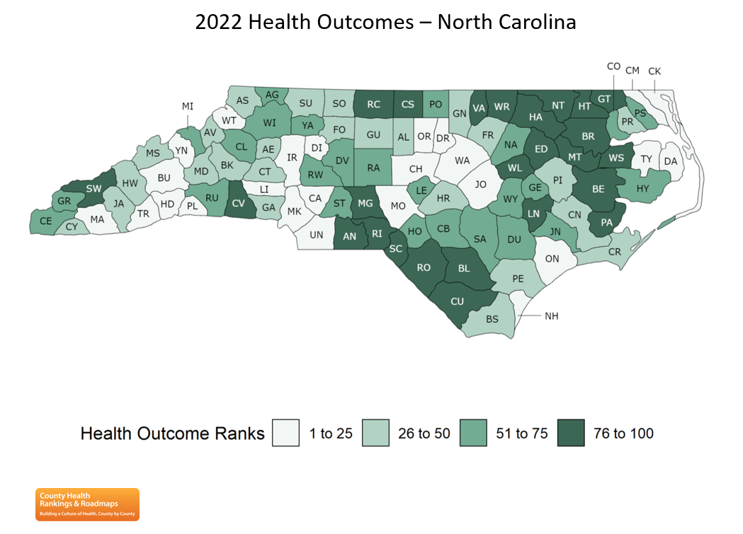

Columbus County ranked 91 out of 100 counties for having the least favorable health outcomes.

Based on the County Health Rankings, Columbus County ranks in the highest tier in the state among unhealthy outcomes. It ranks 94 out of 100 counties among the health outcomes ratings and 90 out of 100 among the health factors ratings. Columbus County was ranked at 100 for the 6 years in a row until improving to 96 for 2016 year.

The summary health factor rankings are based on weighted scores of four types of factors: behavioral, clinical, social and economic, and environmental. The weights for the factors (shown in parentheses in the figure) are based upon a review of the literature and expert input and represent just one way of combining these factors.

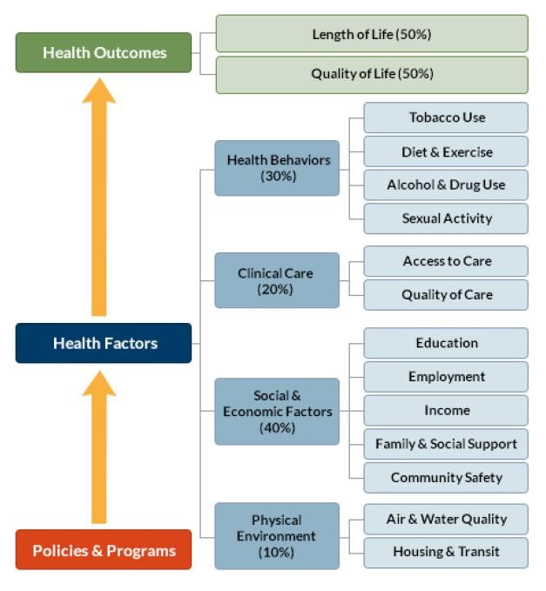

**How Do Counties Rank for Health Factors?**

Health factors in the County Health Rankings represent the focus areas that drive how long and how well we live, including health behaviors (tobacco use, diet & exercise, alcohol & drug use, sexual activity), clinical care (access to care, quality of care), social and economic factors (education, employment, income, family & social support, community safety), and the physical environment (air & water quality, housing & transit).

Columbus County ranked 92 out of 100 in the state in favorable outcomes.

**Rank I •25 • Rank 26-50 "Rank 51-75 •Rank 76-100**

Columbus County ranked 91 out of 100 counties for having the least favorable health outcomes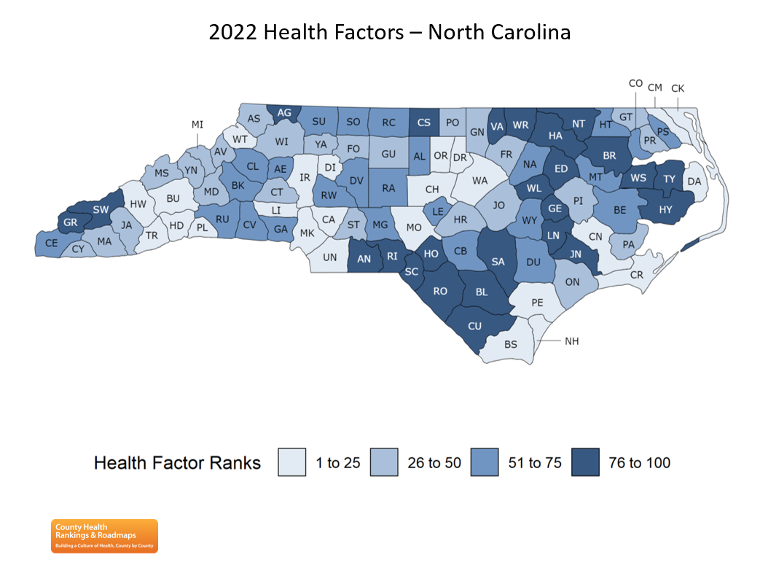

The blue map above shows the distribution of North Carolina's health factors based on weighted scores for health behaviors, clinical care, social and economic factors, and the physical environment. Detailed information on the underlying measures is available at www.countyhealthrankings.org.The map is divided into four quartiles with less color intensity indicating better performance in the respective summary rankings. Columbus County ranked 92 out of 100 counties based on favorable health factors.

**What are the Factors That Drive Health and Health Equity and How Does Housing Play a Role?**

Health is influenced by a range of factors. Social and economic factors, like connected and supportive communities, good schools, stable jobs, and safe neighborhoods, are foundational to achieving long and healthy lives. These social and economic factors also interact with other important drivers of health and health equity. For example, housing that is unaffordable or unstable can either result from poverty or exacerbate it. When our homes are near high performing schools and good jobs, it's easier to get a quality education and earn a living wage, When people live near grocery stores where fresh food is available or close to green spaces and parks, eating healthy and being active is easier. When things like lead, mold, smoke, and other toxins are inside our homes, they can make us sick. And when so much of a paycheck goes toward the rent or mortgage, it makes it hard to afford to go to the doctor, cover the utility bills, or maintain reliable transportation to work or school.

**Health Environment** Columbus ranks approximately the same as the state average for particulate matter and air pollution. The county average is 9.7% while the state average is 9.8% The county is not listed as having any drinking water violations and ranks approximately the same for housing problems. We do face higher than state averages for those individuals who drive alone to work or drive alone and have long distance commutes. The county does have higher home ownership rates than the state average.

**Health Risk Behaviors**

The PLACES Health Risk Behaviors data capture estimated prevalence for various U.S. adult behaviors that pose a risk to health, from binge drinking to smoking, lack of physical inactivity, and short sleep duration.

Adolescents are at risk for many preventable health problems, including substance use disorders, sexually transmitted infections, and injuries from motor vehicle crashes. And there are disparities between race/ethnicity and family income.

https://www.cdc.gov/places/measure-definitions/health-risk-behavi

**Health Outcomes – Mortality and Morbidity**

Leading Causes of Death in North Carolina@ 2023

Location: COLUMBUS

Race: all

Gender: both all (Hispanic, Non-Hispanic, and

Hispanic Origin: Unknown)

Age: O - 99 years

Note: Age 99 indicates age 99 years or older.

|  |  |  |  |
| --- | --- | --- | --- |
| Rank |  | Cause | Number |
|  | 1 | Diseases of heart | 926 |
|  | 2 | Cancer | 704 |
|  | 3 | Chronic lower respiratory diseases | 242 |
|  | 4 | Cerebrovascular diseases | 223 |
|  | **5** | Diabetes mellitus | 163 |
|  | 6 | Motor vehicle injuries | 99 |
|  | 7 | Alzheimer's disease | 24 |
|  | 8 | All other unintentional injuries | 221 |
|  | 9 | Covid | 305 |
|  | 10 | Nephritis, nephrotic syndrome and nephrosis | 89 |
|  | Total Deaths All Causes | | 4194 |

[NCDHHS: DPH: NC SCHS: Statistics and Reports: 2025 County Health Data Book](https://schs.dph.ncdhhs.gov/data/databook/)

### Cancer

The N.C. Division of Public Health reports that cancer is now the leading cause of death in North Carolina surpassing heart disease. In Columbus County, the cancer rate is 17.8% compared to the state rate of 20.9%. Lung cancer is the leading cause of cancer death in Columbus County (July 2020 Cancer Profiles). Please refer to the link below to review fact sheet related to cancer statistics and the risk factors and Interventions related to these diseases in Columbus County, North Carolina and the United States.

|  |  |  |
| --- | --- | --- |
| Projected Types of Cancer | Columbus County | North Carolina |
| Lung/Bronchus  Colon/Rectum  Female Breast  Prostrate  Melanoma  All Cancers | 253  142  296  249  103  1724 | 9375  4838  11,315  7739  1774  64,274 |
|  |  |  |
|  |  |  |
|  |  |  |
|  |  |  |

NC Central Cancer Registry, 01/2025

### Heart Disease

Heart Disease is the second leading cause of death for men and women in North Carolina. The risk of heart disease increases as a person’s age increases. In addition to behavioral risk factors, obesity, high blood pressure, high cholesterol and diabetes are other known risk factors for heart disease In Columbus, the heart mortality rate is 27.9% compared to the state rate of 20.2%.

[NC County Health Data - NCIOM](https://nciom.org/nc-health-data/map/)

Charts included on the following two pages indicate statewide and county trends in key health indicators and include comparisons to Columbus County for Colorectal Cancer, Trachea, Bronchus and Lung Cancer, Female Breast Cancer and Prostate Cancer, Cardiovascular, Heart, Stroke and Diabetes death rates per 100,000 residents.

[Columbus.pdf (ncdhhs.gov)](https://schs.dph.ncdhhs.gov/data/keyindicators/reports/Columbus.pdf)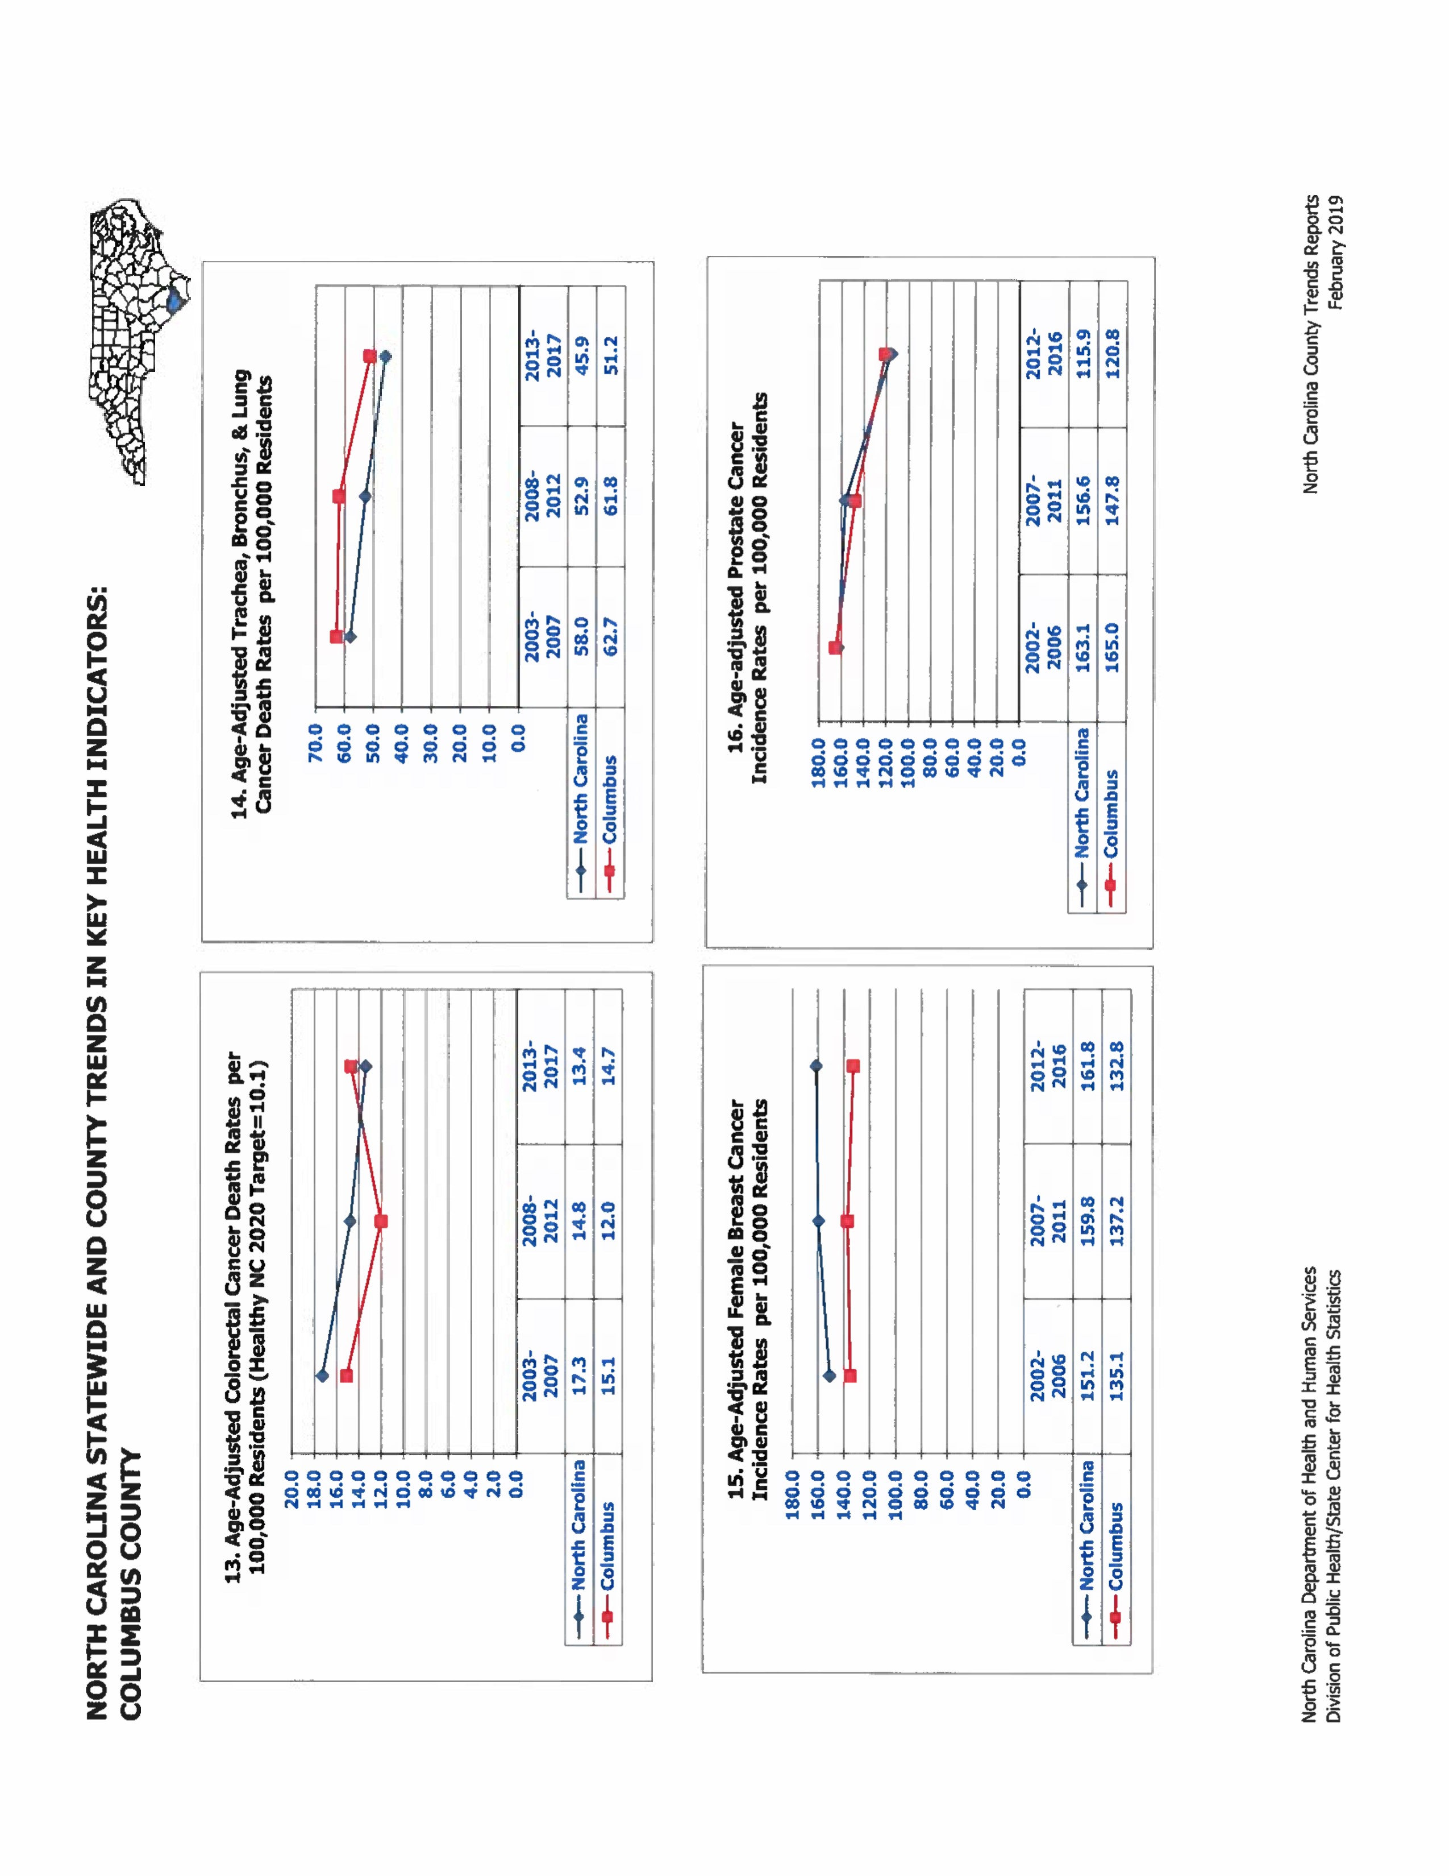

## 

**Health Services – Preventive Clinical and Access**

Due to the lower-income status of the county, the United States Census designates Columbus County as “rural”. Columbus has an unemployment rate of 12.6% (2012) and is considered a Tier 1 county, which means it is economically depressed by the State Department of Commerce and ranks 91 out of 100 for health outcomes in North Carolina.

**Clinical Preventive Services**

### Screening

Columbus County screening rates for some of the most widely recommended screenings are better than the state and national rates. Various events are held throughout the year where free screenings are provided to the public for regular cholesterol, blood pressure and bone density checks.

## **Health Care Access**

At 19.0%, Columbus County has one of the highest rates of uninsured adults ages 19 and over. Additionally, 5% of our children, ages 0-18, lack health insurance coverage, which is in line with the state average of 5%. (2019 County Rankings and Roadmaps). Our Medicaid population is at 31% compared to the state average of 21.2% We have fewer health care physicians per 10,000 residents compared to the state level, few dentists and birth attendants. Access to Psychiatrists and Psychologists is 0.2 per 10,000 as compared to 3.5 per 10,000 residents at the state level. Mental health providers in Columbus County see an average of 843 patients per year which represents a .0355% decrease from the previous year. This has been changing over time in Columbus County, NC in comparison to neighboring states. Data provided by The County Health Rankings and Roadmap, 2023.

<http://nciom.org/nc-health-data/nc-data/>

<https://www.countyhealthrankings.org/rankings/data/nc>

## **Community Feedback-A Community Survey**

### Community Survey

Qualitative data was gathered by conducting a community survey with a total of 295 responses from community members. The prioritization process included review and analysis of this primary, qualitative community feedback to determine priorities for healthcare interventions within Columbus County.

## **Identified Priority Health Needs & Related Health Assets**

**To select priorities and related strategies, the following criteria were considered:**

* Data from the Community Health Assessment Survey indicated the issue as an important community need.
* Columbus Regional Healthcare System has the capacity to impact the issue.
* Addressing a selected issue holds the potential to affect other key health conditions, therefore creating a multiplying effect.
* Strategies selected align with and support Columbus Regional Healthcare System’s mission and strategic direction.
* Strategies selected take into consideration current assets in both the community and within Columbus Regional Healthcare System

In considering the above, the following priorities were selected:

### 1. Heart Disease and Stroke

Cardiovascular disease includes the second and fourth leading cause of death in North Carolina – heart disease and stroke- and account for nearly 26% of all deaths in North Carolina.

Heart disease is the number one leading cause of death in Columbus County attributing to 1,115 deaths in Columbus County and 90,942 deaths in North Carolina between 2013 and 2017 (NCSCHS, 2017). While high blood pressure, smoking and physical inactivity are considered four major risk factors, other factors such as obesity and diabetes are also considered risk factors.

### 2. Cancer

Between 2013-2017, 96,225 people in North Carolina died from cancer, 658 died in that same time period in Columbus County making it the second leading cause of death compared to the number one ranking statewide. Lung cancer is the leading cause of cancer death in Columbus County accounting for 239 of the county cancer deaths.

It is generally recognized that most cancers are related to personal lifestyle or environmental factors (smoking and diet). Other factors (age, gender, family history of a specific cancer) are also associated with the development of cancer and aid in the identification of people at high risk.

### 3. Diabetes

The prevalence of diabetes continues to be high in Columbus County as the 5h leading cause of death in 2017. Diabetes is also a major cause of death and disability in North Carolina and the nation. With a greater prevalence of obesity and an increasing elderly population, diabetes is approaching epidemic proportions in North Carolina. The number of diabetes related deaths in Columbus County from 2013-107 was 92 and 13,549 deaths statewide.

4. The need for drug and alcohol resources were noted in the health assessment. CRHS along with

other county agencies and the community came together to develop the Columbus County

Opioid and other Substance Use Needs Assessment. Findings from this assessment are being.

Implemented in 2025.

[2022-Opiod-Strategic-Plan-Columbus-County1.pdf](https://crhealthcare.org/wp-content/uploads/2022/10/2022-Opiod-Strategic-Plan-Columbus-County1.pdf)

## **Implementation Strategies**

After identification of health care priorities, additional planning meetings will be facilitated with Columbus Regional Healthcare System leaders and the Community Health Assessment Committee to develop strategic initiatives to address the health care need priorities.

**Columbus Regional Healthcare System’s Implementation Strategies include:**

1. Heart disease and stroke- To address heart disease and stroke, Columbus Regional Healthcare System will focus on:
   1. Community education and efforts to increase early heart disease/stroke awareness and detection.
   2. Increase at risk population screenings for heart disease. More specifically, initiatives include tracking number of referrals to cardiac rehabilitation services at CRHS, continuing to partnership with outside physicians specializing in cardiology and vascular issues.
   3. Offer community education programs on topics related to heart disease and stroke awareness including cholesterol screenings, blood pressure checks and education related to preventative measures such as physical exercise and weight loss. Continue inclusion of screenings and education into current community programs, health fairs and community outreach events. CRHS has initiated participation in local health fairs in conjunction with the Columbus County Farmer’s Market, G&G Healthcare, community screenings at churches and within the hospital. There have been various screenings for vascular and hernia during the past year.
   4. Ongoing focus to increase heart disease education and early detection through a partnership with Columbus County Health Department and Columbus County Healthy Carolinians, whose mission is to coordinate and facilitate county-wide health initiatives that create an environment supporting total health.

* 1. Columbus Regional Healthcare System employees are offered an annual wellness program that includes wellness labs, immunization compliance and identification of hypertension and other chronic illnesses.

* 1. Code Stroke Initiative. Stroke is not an acronym; it is really a diagnosis. Columbus Regional Healthcare System is now a fully certified Acute Stroke Ready Hospital. The Emergency Department Staff nurses and physicians are prepared to diagnose and treat a stroke patient immediately. There are stroke coordinators and team of staff nurses prepared to provide additional education for groups throughout the community. They use the F.A.S.T. educational program to train individuals; the sooner an individual receives treatment, the better the outcomes.

* 1. Expanded relationship with Cape Fear Heart Associates, a cardiology physician group from New Hanover County, to provide efficient, convenient cardiac care to the citizens of Columbus County. A helicopter is now located full-time at CRHS to transport critical care patients to New Hanover Regional Healthcare for immediate intervention particularly as it relates to cardiac care and stroke.

* 1. The Care Transitions program funded through the Duke Endowment will provide staff to collaborate with patients and their healthcare team upon discharge from CRHS to improve health outcomes and reduce hospital readmissions. The Care Transitions Team will expand upon current work done with patients following discharge from the hospital. A software solution to further assist Care Managers and the Transitions team are included in the grant.

1. Cancer- To address Cancer, Columbus Regional will focus on the following:
   1. Increasing education in the community
   2. Implement cancer screening programs into current community benefit related activities.

Initiatives include:

* + 1. Donayre Care Cancer Center (DCCC), partnering with Levine Cancer Institute in Charlotte are providing services with the hospital.
    2. DCCC now offers free screenings on-site and throughout the county for prostate, colon and anal cancers, free mammograms and two staff have now received national certification as specialized. nurses who can provide breast exams out in the community. Code 911 is a project where staff are working with local emergency responders to educate them on the dangers of developing certain types of cancer due to exposure to hazardous materials. Prostate screenings have been held for two years in conjunction with local urologists.
    3. The Donayre Cancer Care Center (DCCC) facilitates the Columbus Cancer Champions Support group for all cancer patients. Attendees meet monthly and hear from various speakers including Providers, Dieticians, Physical Therapy and others. The Caring for the Caregiver is another Support Group sponsored by DCCC and is led by the Columbus Regional Healthcare System Chaplain.

Because of the partnership with Levine Cancer Institute, Donayre Cancer Care Center has access to Clinical Trials. These research studies are designed to answer all questions and concerns.

1. Diabetes- Columbus Regional Healthcare System will address Diabetes by:

1) Increasing education

2) Participate and offer community events to provide free screenings for patients at risk for this chronic disease while offering resources for management and treatment options.

* + 1. For hospitalized patients at Columbus Regional Healthcare, a diabetes educator with advanced diabetes management certification, is available to help educate and manage their diabetes during their hospital stay.

* + 1. Columbus Regional Healthcare System increases community awareness through education of diabetes signs and symptoms, treatment options and preventative measures at monthly support group meetings. Provides space and financial support including group leader and program speakers.

* + 1. The Diabetes Education Program at CRHS is recognized by the American Diabetes Association as meeting the National Standards for Diabetes Self Management Education. The program provides group classes and individual diabetes education sessions and self-management through dietician nutritional counseling. Education is provided by a multidisciplinary staff including a certified diabetes educator nurse, certified diabetes educator dietitian, podiatrists, exercise physiologists and pharmacists. Participants are offered both day and night options for classes.

1. Illegal use of prescription drugs remains a high priority in our county. CRHS has implemented a MedSafe program where specialized containers are placed in the main lobby for community residents to dispose of unused medication safely and help protest them. environment. Overuse and illegal use of prescription drugs has been addressed by our ER and CME on prescribing pain medication to patients has been offered twice this year to area physicians. Policies are in place for individuals coming into the emergency room for treatment and for patients discharging from the hospital related to number of pills, refills and referrals to primary care providers. Policies are housed on the hospital website, “escoop”, and addresses procedures updated and reviewed in 2016 specifying assessment and intervention activities, patient and staff education requirements and performance improvement activities related to Patient Pain Management**. (Pain Management and Reassessment in the Emergency Department.)**  A pain management clinic has been opened by the hospital to assist in the control of prescription drugs. The hospital received a grant from Kate B. Reynold to study the use of opioids in the county. This research was used as our county prepared our Substance Abuse Assessment Plan that was approved by the Attorney General. This plan called for several options for those suffering from addiction, including a substance abuse facility to house 18 of our county residents and the implementation of a drug court.

[2022-Opiod-Strategic-Plan-Columbus-County1.pdf](https://crhealthcare.org/wp-content/uploads/2022/10/2022-Opiod-Strategic-Plan-Columbus-County1.pdf)

1. General Health Initiatives will continue to be a significant factor in our community outreach efforts. We will continue to sponsor general health fairs throughout the county and partner with other public agencies and physicians to offer health screenings. Our CRHS Chaplain will continue outreach with local churches and arrange for presentations related to health issues identified by these partners. CRHS will continue to operate a Hurricane Command Center within the hospital during periods of tropical disturbances. CRHS applied for and received funds from the Golden Leaf Foundation to establish a private water access system to address concerns over loss of water during Hurricane Florence when the city supply line was damaged. CRHS will continue to build on the relationship with the Columbus County Health Department and work together to address health concerns identified in our 2019 Community Health Needs Assessment. CRHS continues to fund an Employee Emergency Care Fund through the CRHS Foundation and employee contributions to assist those employees who have suffered loss due to natural disaster or a health crisis. Funds dispersed and collected are documented in Form 990 each year.

**2025 Columbus Regional Healthcare Community Health Assessment Survey**

**Do you live in Columbus County? ________ yes, Zip Code__________ No_____________** Please answer the following questions: (1) Strongly disagree (2) Disagree (3) Neutral (4) Agree (5)Strongly Agree

|  |  |  |
| --- | --- | --- |
| **1.How do you feel about this statement, “There is good health care in Columbus County. Consider the cost and quality, number of options, and availability of healthcare in the county** | | **1 2 3 4 5** |
| **2.How do you feel about this statement? Columbus County is a good place to raise children.** | | **1 2 3 4 5** |
| **3.How do you feel about this statement? Columbus County is a good place to grow old. Consider elder friendly housing, transportation to medical services and recreation for the elderly.** | | **1 2 3 4 5** |
| **4.How do you feel about this statement? Are there plenty of economic opportunities in Columbus County? Consider number and quality of jobs, higher education opportunities and affordable housing.** |  |
| **5.How do you feel about this statement? Columbus County is a safe place to live. How safe do you feel at home, in the workplace, playgrounds and parks?** |  |
| **6.How do you feel about this statement? There is plenty of help for people during times of need. Consider support groups, neighbors, faith groups community organizations and emergency money assistance.** |  |

**The next set of questions will ask about community problems, issues and services that are important to you,**

**7. Please look at this list of community issues. In your opinion, which one issue most affects the quality of life in Columbus County? Please choose only one.**

_____Pollution ______Neglect and Abuse

____ Dropping out of school ______Elder Abuse ____Child Abuse

____Low income/poverty ______ Domestic Violence

____Lack of/inadequate health ______Violent crime (murder, assault, etc.)

Insurance ______Teen Pregnancy

____Hopelessness _____ Theft

____Discrimination/Racism ____ Rape/Sexual Assault[1]

____Lack of community support ____ Drug/Alcohol Abuse

____No opinion

8. In your opinion, which of the following services needs the most improvement in your neighborhood or community?

_____Animal control _____Drug and Alcohol Prevention

_____Child Care options _____ Counseling/Mental Health/Support Groups

_____Elder Care Options _____ Drug and Alcohol Abuse Treatment

_____Services for Disabled People _____ Better/More Recreational Services

_____More affordable/better housing (parks, trails, community centers, etc.)

_____Better/healthier food choices _____Healthy family activities

_____More affordable housing ____ Positive teen activities

_____Availability of employment ____Transportation options

_____Higher paying Employment ____Road Maintenance

_____More health care providers ____ Road Safety

What kind? _________________________________________

**HEALTH INFORMATION**

9. In your opinion, which one health behavior do people in your own community need more information about?

____Eating well/nutrition ___ going to dentist for a checkup/preventive care.

____Exercising ___Going to doctor for yearly check- ups and screenings.

____Managing weight _____Getting prenatal care during pregnancy.

____Using child safety seats _____Getting flu shots and other vaccines.

____Driving safely _____Quitting smoking/Tobacco use prevention.

____Childcare/parenting ____ Domestic violence prevention

____Elder Care Caring for family members with special needs.

____Suicide Prevention __ _Preventing pregnancy /sexually transmitted disease.

____Stress Management ____Substance abuse prevention (ex: drugs and alcohol.)

____Anger Management ____ Peparing for a disaster.

____Crime Prevention ____Other

10. Where do you get most of your health information? Choose only one.

_____ Friends and Family ____ Hospital

_____ Doctor /Nurse _____Health Department

_____ Pharmacists ____Help Lines

_____ Church _____Books/Magazines

_____ Internet ___Other

_____My Child’s School

11. Do you have children between the ages of 9 and 19 for which you are caregiver?

________ yes, ____ no

12. Which of the following health topics do you think your child/children need more information about?

a. ____Dental Hygiene f. _____Tobacco k._____ reckless driving/speeding

b._____ Sexual Relations g. ____STD’S L. _____ Mental Health Issues

c. ____Eating Disorders h. ___ Nutrition M. _____Suicide Prevention

d. ____Asthma Management I. ____Alcohol N. _____Other

e. ____Diabetes Management j. ___Drug Abuse O. _____None of the above

**PERSONAL HEALTH**

The next questions are about your own personal health. Answers you provide will not be linked to you in any way.

13. Would you say in general, your health is

_______Excellent, _________Very Good, _____ Good, _______Fair. _______Poor.

________Don’t know, not sure, _______Choose not to answer.

14. Have you ever been told by a doctor, nurse or other health professional that you have any of the health conditions listed below:

a. Asthma Yes______ No______

b. Depression/Anxiety Yes______ No______

c. High Blood Pressure Yes______ No______

d. High Cholesterol Yes_____ No______

e. Diabetes Yes_____ No______

f. Osteoporosis Yes_____ No_____

g. Obesity/Overweight Yes_____ No______

h. Heart disease Yes____ No ______

if. Cancer Yes_____ No______ Type____________

j. Arthritis Yes_____ No______

k. COPD Yes_____ No______

l. Domestic Violence Yes_____ No______

M. Dementia Yes____ No______

N. Parkinsons Yes_____ No______

O. Other Please specify______________

15. In the past thirty days, have there been days when feeling sad or worried kept you from going about your normal business?  
______Yes _____No

______Not sure ____Refuse to answer.

16. In the past thirty days, have you had any physical pain or health problems that made it hard for you to do your usual activities such as driving, working around the house, or going to work?

_____ Yes, ______No _____Not Sure ______Refuse to answer.

17.During a normal week, other than in your regular job, do you engage in any physical activity or exercise that lasts at least one hour?

____Yes, ______No _____Not Sure ______Refuse to answer.

18. Where do you go to exercise or engage in physical activity? Check all that apply.

a. _____ YMCA _____ d. Private Gym

b. _____ Park _____e. Home

c. _____ Public Recreation Facility _____f. Other

19. What are some reasons you do not exercise for at least a half hour during a normal week?

a. _____My job is physical or hard labor g.______ I do not like to exercise.

b. _____Exercise is not important to me h. _____ It cost too much.

c. ____ I do not have access to things I need I. ______there is not safe place to exercise.

such as pool, golf course or a track.

d.____ I do not have enough time J. ____ I am too tired to exercise

e.____ I would need childcare, and I don’t have it k._____ I am physical disabled

f. ____ I need an exercise partner l._____ I do not know.

20. Do you eat or drink the following vegetables, fruit or fruit drinks each week?

Fruit_______ Vegetables________ 100% Fruit Juice___________

Never eat vegetables______ Never eat fruit Never drink fruit juice_____________

21. Have you been exposed to secondhand smoke in the past year?

_______ Yes, _______ No

22. If yes, where do you think, you were exposed to secondhand smoke most often. Check only one place.

a. _______Home e. ________ Schools

b. ____ Workplace f. ______Other _______________________

c. ______ Hospitals

d. _____ Restaurants

23. Do you currently smoke?

_________ Yes, _______ No

24. If yes, where would you go for help if you wanted to quit?

a. ____Quit Line NC f. ___ Health Department

b. _____Doctor g.____ I do not know.

c. _______Church h. ___Other

d. ______ Pharmacy I. ______I do not want to quit.

e. ______ Private counselor/therapist

25. Where do you go most often when you are sick?

______Doctor’s Office ______ Medical Clinic

______Health Department ______Urgent Care

______ Hospital _____ other

26. Do you have health insurance?

_______ Yes, _____ No

If yes, what is your primary health insurance plan?

a _____ State Employee Health Plan

b _____Blue Cross and Blue Shield of NC

c ___Other private health insurance plan purchased from employer or workplace

d_____ Medicare

e ____ Other private health insurance purchases directly from an insurance company

f _____Medicaid or Carolina ACCESS or Health Choice

g ____ The Military, Tricare, Champus, or the Veteran’s Administration

h ____ Indian Health Service

I ____ Other

J ____ No health plan of any kind

27. In the past 12 months, have you had a problem getting the health care that you needed for you personally or for a family member from any type of health care provider, dentist, pharmacy, or other facility?

________ Yes, ______No

28. If you said yes, what type of provider of facility did you, or a family member, have trouble getting health care from?

_____Dentist _____ General Practitioner _____ Eye care, ophthalmologist

_____ Pharmacy _____ Prescriptions _____ Pediatrician

_____OB/GYN _____Health Department _____Hospital

_____Urgent Care _____Medical Clinic _____Specialist (Type) ____

29. Which of these problems prevented you or your family member from getting the necessary health care?

a. ___ No health insurance

b. ____ Insurance did not cover what I needed.

c. ____ My/our share of the cost was too high.

d. ____ Doctor would not take my/our insurance or Medicaid.

e. _____ Hospital would not take our insurance.

f. _____ Pharmacy would not take my/our insurance.

g. _____ Dentist would not take my/our insurance or Medicaid.

h. ___ No way to get there.

I. _____ Did not know where to go.

j. ____ Could not get an appointment.

k.____ The wait was too long

30. If a friend or family member needed counseling for mental health or a drug/alcohol abuse problem, who is the first person you would tell them to talk to? Please choose one.

a. ____ private counselor or therapist e.______ Doctor

b. _____ Support Group (A.A. Al Anon) f. ______ Minister, Religious Official

c. _____School Counselor g. _____ Mental Health Agency

d. _____Do not know h___ Other.

**EMERGENCY PREPAREDNESS**

31. Does your home have a working smoke and carbon monoxide detector?

_______Yes, smoke detectors only _______ Yes, carbon monoxide detectors only

_______ Yes, both _______ No

______Don’t know.

32. Does your family have a basic emergency supply kit?

(water, flashlight, prescriptions, first aid supplies, blankets, batteries, non-perishable food)

_______ Yes, ______ No _______Do not know.

33.In a large-scale disaster or emergency, what would be your main way of communicating with family?

______a. regular home phone _____e. 2- way radio

______b. cell phone _____f. Other, describe _______

______c. email ____g. I don’t know.

______d. pager

34. What would be the main reason you might not evacuate if asked to do so?

a. ____ Lack of transportation g. ___Concern about traffic and inability to get out.

b. ___Lack of trust in public officials h. _____Health problems (could not be moved

c. ____Concern about personal safety

d.____ Concern about family safety I. __Other

e. ___Concern about leaving personal property behind

f. ____Concern about leaving pets j. ____ Don’t know, not sure.

**DEMOGRAPHIC INFORMATION**

35. How old are you?

a. _____Under 18

b. _____18-24

c. _____25-44

d. _____45-54

e. _____55-59

f. _____ 60-64

g._____ 65-74

h. _____75+

36. What is your gender?

______Male _____ Female _____Transgender_____ Prefer not to respond.

**S está llevando a cabo una encuesta de Evaluación de necesidades de salud comunitaria (CHNA) para comprender mejor las preocupaciones y necesidades de salud de nuestra comunidad. La información obtenida de CHNA se utilizará en el desarrollo de un plan de acción para mejorar la salud de la comunidad. Si tiene al menos 18 años y es residente del condado de Columbus, complete la siguiente encuesta. Solo uno por hogar. Todos los encuestados permanecerán anónimos. No incluya su nombre u otros identificadores.**

1. (Marque solo uno) ¿Cómo califica su propia salud? _ Excelente _ Muy buena __Buena __Feliz __Pobre _ No sé / No estoy seguro

2. (Marque todo lo que corresponda) ¿Alguna vez le ha dicho un médico, enfermera o profesional de la salud que tiene alguno de los siguientes**?** __Diabetes __Colesterol alto __Depresión __Osteoporosis __ Enfermedad cardíaca */* Angina Cáncer __Asma

_Demencia _ Sobrepeso */* Obesidad __ Enfermedad Pulmonar Presión arterial alta __Artritis _ _Violencia doméstica__ Parkinson_ Otro (especifique)

3. (Marque todo lo que corresponda) ¿Cuál de estos problemas le impidió a usted o su familia obtener la atención médica necesaria? __Cultural */* Creencias de salud __ No hay citas disponibles___ Falta de comprensión de la necesidad_ Falta de seguro

Transporte_ Miedo (no está listo para enfrentar un problema de salud) _ Incapaz de pagar */* costo */* no puede pagar __NO importante _Ninguno ___Otro *(*especifique)

4. (Marque solo uno) ¿Qué ha afectado la calidad de la atención médica que recibió? __Capacidad de leer y escribir */* Educación

__Raza _No aplicable __Barrera */* intérprete */* traductor de idiomas__Económico (bajos ingresos, sin seguro, etc.)

5. (Marque todo lo que corresponda) ¿Dónde obtienen usted y su familia la mayor parte de su información médica? _Centro de educación en salud _Búsqueda de internet__ Televisión __Hospital__ Hoja informativa__Radio Familia o Amigos _Doctor */* Profesional de salud

__Periódico__*/* Revistas _Departamento de Salud __Iglesia __Escuela _Líneas de ayuda

6. (Marque solo uno) ¿De qué cree que muere la mayoría de las personas en su comunidad? __Asma */* Enfermedad Pulmonar Accidente Cerebrovascular / Enfermedad CerebrovascularHomicidio */* Violencia __Enfermedad Cardíaca__Diabetes __Muertesde Vehículos de Motor _Cáncer __Suicidio __HIV*/*SIDA _Otro (por favor especifique) _

7. (Marque solo uno) ¿Cuál es el mayor problema o preocupación de salud en su comunidad? _Abuso de alcohol en adolescentes_Embarazo __Uso ilegal de drogas__ Abuso infantil _Obesidad _Vehículos se bloquea _ Prescripción Abuso de drogas _Pandillas */* Violencia _Mental __Salud _Asma __Uso de Nicotina Use (vaporizadores, cigarrillos) _Salud Dental _, Clamidia) __Otros (especifique)

8. (Marque solo uno) ¿Cuál de las siguientes opciones afecta más la calidad de vida en su condado? Contaminación (aire, agua, tierra) Salir de la escuela _Bajos ingresos / pobreza__ Falta de vivienda_ Falta de seguro médico inadecuado Falta de esperanza _Discriminación */* racismo __ Falta de apoyo comunitario__Negligencia y abuso ___ Violencia doméstica _Crimen (asesinato, asalto, robo, violación */* agresión sexual) __Ninguno _Otros (especifique)

9. (Marque solo tres) ¿Qué necesita su comunidad para mejorar la salud de su familia, amigos y vecinos? Acceso a la comida Servicios de salud mental Opciones de alimentos más saludables Oportunidades laborales Servicios para discapacitados __Instalaciones de recreación _ Lugares seguros para caminar */* jugar _ Programas después de la escuela Servicios de bienestar

_Transporte___ Programas para personas mayores __Médicos especializados __Servicios de salud complementarios__ Rehabilitación__ Servicios

Servicios de salud __ Rehabilitación

10. (Marque todo lo que corresponda) ¿Cuál de las siguientes pruebas preventivas ha tenido en los últimos 12 meses?

**_**Mamografía (si es mujer) _Examen de detección de cáncer de próstata (si es hombre) __Examen de colon */ r*ectal _ _Control de azúcar en sangre _ Examen de colesterol __Examen de audición Prueba de densidad ósea__ Examen físico __Frotis de papilla (si es mujer)_Gripe _Control de presión sanguínea _Examen de cáncer de piel__Examen de VIH_Examen de detección cardiovascular __Limpieza dental */ r*ayos X_ Ninguno de los anteriores _Otros (especifique).

11. (Marque todo lo que corresponda) ¿De cuáles de los siguientes problemas de salud ha recibido información en los últimos 12 meses?__Presión Arterial __Salud Mental_Abuso de sustancias__Colesterol __Emergencia Preparaciones__Nutrición

_Distracciones */* cinturones de seguridad / asientos de seguridad para niños _HIV */* Infecciones de transmisión sexual __Salud Familiar _Vacunas */* Inmunizaciones __Cáncer __de

12. (Marque todo lo que corresponda) ¿Siente que las personas en su comunidad carecen de los fondos para alguno de los siguientes? ___Comida __Hogar */* Refugio __Medicina __Seguro de salud _Transporte_ Asistencia médica asequible */* Copago */* Deducible _Utilidades _Otros (especifique)

13. (Marque solo uno) Aparte de su trabajo habitual, ¿cuántos días a la semana realiza actividad física durante al menos 30 minutos que le hacen "sudar"? __Cero días __Uno a dos (1-2) días a la semana _Tres a cuatro (3-4) días a la semana __Cinco (5) o más días a la semana

14. (Marque solo uno) En promedio, ¿con qué frecuencia come frutas o verduras? __Una vez al día __Una *v*ez a la semana __Una vez al mes_ *V*arias veces al día _*V*arias veces a la semana __Nunca

15. (Marque solo uno) ¿Tiene su familia un botiquín básico de suministros de emergencia? (Estos botiquines incluyen agua, alimentos no perecederos, cualquier receta necesaria**,** suministros de primeros auxilios, linternas y baterías, abrelatas, mantas, etc. no eléctricos) __Si_No__No sé */* No estoy seguro

16. (Marque solo uno) ¿Cuál sería su forma principal de obtener información de las autoridades en un desastre o emergencia a gran escala?**_**Televisión_Mensaje de texto_Sitio de red social ___ Vecinos__ Radio__ Medios impresos (ej.: periódico) _Internet __Otros (por favor especifique

17. (Marque solo uno) Si las autoridades públicas anunciaran una evacuación obligatoria de su vecindario o comunidad debido a un desastre o emergenciaa gran escala, ¿evacuaría? __S1_No _No sé */* no estoy seguro

18. (Marque solo uno) ¿Cuál sería la razón principal por la que no podría evacuar si se le pide que lo haga? __ No aplicable Preocupación por la seguridad familiar. Problemas de salud (no se pudo trasladar) _Preocupación por la seguridad personal

Falta de transporte No sé __Preocupación por el tráfico */* incapacidad para salir. Preocupación por dejar la propiedad atrás __ Falta de confianzaen los funcionarios públicos _ Preocupación por dejar a las mascotas **___**Otro (Por favor especificar) Información demográfica

19. Soy: __Masculino__ Femenino __Transgénero Género no conforme

20. Mi edad es _ 19-24 ____ 25-34 ___ 35-44_ 45-54__ 55_64_65*-*74_*_ 7*5+ *2*1 ¿Cuál es su código postal?

22. Mi raza es: Blanca */* Caucásica__ Nativo Americano / Nativo de Alaska_ Islas del Pacífico__ Negra */* Afroamericana Asiática ----- Dos o másrazas Otra (por favor especifique)

23. ¿Es usted de origen hispano, latino o español ___Si __No?

24. ¿Tiene actualmente seguro de salud _____ Sí ____ No _____ tenía en un trabajo anterior?

25. ¿Vive o trabaja en el condado de Columbus ____ Ambos ____ Vive _____ Trabaja ____ Ninguno?

26. Cuando busca atención, ¿en qué hospital visita primero? (Marque solo uno) _____Columbus Regional Healthcare System ______Bladen County Hospital _____ Southeastern Regional Medical Center ______ Brunswick County Hospital _____ New Hanover Regional ____ Otro (especifique)

27. En los últimos 12 meses, ¿tuvo problemas para obtener la atención médica que necesitaba para usted personalmente o para un miembro de su familia de cualquier tipo de proveedor de atención médica, dentista, farmacia u otro centro?

________Sí ______No

28. Si dijo que sí, ¿de qué tipo de proveedor de centro tuvo problemas para obtener atención médica usted o un miembro de su familia?

_____Dentista _____Médico de cabecera _____ Cuidado de los ojos, oftalmólogo

_____Farmacia _____Prescripciones _____Pediatra

_____OB/ginecología Departamento _____Health _____Hospital

_____Urgent Cuidado _____Medical Clínica _____Specialist (Tipo) __________

29. ¿Cuál de estos problemas le impidió a usted o a su familiar obtener la atención médica necesaria?

a. ______ Sin seguro médico

b. _____ seguro no cubría lo que necesitaba

c. _____ Mi parte del costo era demasiado alta

d. _____ médico no aceptaría mi/nuestro seguro o Medicaid

e. _____ Hospital no aceptaría nuestro seguro

f. _____ Farmacia no aceptaría mi/nuestro seguro

g. _____ dentista no aceptaría mi/nuestro seguro o Medicaid

h. _____ No hay forma de llegar allí

i. _____ No sabía a dónde ir

j. _____ No se pudo obtener una cita

k._____ La espera fue demasiado larga

30. Si un amigo o familiar necesitara asesoramiento por un problema de salud mental o abuso de drogas / / alcohol, ¿quién es la primera persona con la que le diría que hable? Por favor, elija uno.

a. _____ consejero o terapeuta privado e.______ Doctor

b. Grupo de Apoyo _____ (A.A. Al Anon) f. ______ Ministro, Oficial Religioso

c. _____School Consejero g. Agencia _____ de Salud Mental

d. _____Do no sé h, _____ Otros

**PREPARACIÓN PARA EMERGENCIAS**

31. ¿Su hogar tiene un detector de humo y monóxido de carbono que funcione?

_______Yes, solo detectores de humo _______ Sí, solo detectores de monóxido de carbono

_______ Sí, ambos _______No

______No sé

32. ¿Su familia tiene un kit básico de suministros de emergencia?

(agua, linterna, recetas, botiquín de primeros auxilios, mantas, baterías, alimentos no perecederos)

_______Sí ______No _______No sé

33.In un desastre o emergencia a gran escala, lo principal sería comunicarse con la familia.

______a. Teléfono residencial normal _____e. Radio de 2 vías

______b. teléfono celular _____f. Otros, describa _______

______c. Correo electrónico ____g. No sé

______d. buscapersonas

34. ¿Cuál sería la razón principal por la que no podría evacuar si se le pidiera que lo hiciera?

a. ____ Falta de transporte g. _____Concern sobre el tráfico y la imposibilidad de salir

b. ____Lack de confianza en los funcionarios públicos h. _____Health problemas (no se pudo mover

c. ____Concern sobre seguridad personal

d.____ Preocupación por la seguridad de la familia i. ____Other

e. ____Concern sobre dejar atrás la propiedad personal

f. ____Concern sobre dejar mascotas j. ____ No lo sé, no estoy seguro

**INFORMACIÓN DEMOGRÁFICA**

35. ¿Qué edad tienes?

a. _____Under 18

b. _____18-24

c. _____25-44

d. _____45-54

e. _____55-59

f. _____ 60-64

g._____ 65-74

h. _____75+

36. ¿Cuál es tu género?

______Male _____ Mujer _____Transgender_____ Prefiero no responde

**APPENDIX**



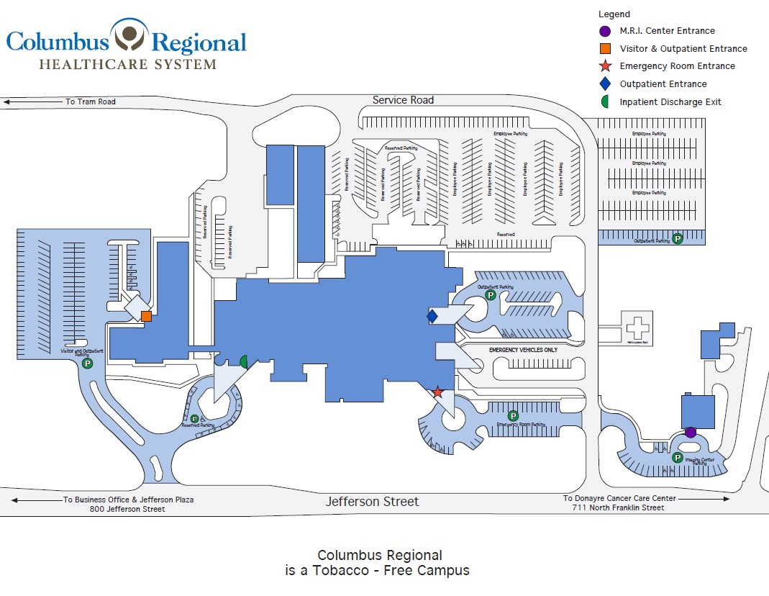

**ACKNOWLEDGEMENTS TO THOSE WHO ASSISTED IN THE DEVELOPMENT OF OUR 2019 COMMUNITY HEALTH NEEDS ASSESSMENT**

**Columbus County 203-25 Wellness Initiative Committee**

|  |  |
| --- | --- |
| Columbus County Wellness Initiative | Agency |
| Rhonda Dutton | Col. Co. Youth and Families |
| Dr. Dalton Dockery | Col. Co. Agricultural Extension Service |
| Melissa Swain | YMCA Columbus County |
| Joseph Washburn | Whiteville First Presbyterian Church |
| Jeremy Simmons | Chaplain CRHS and African American Churches Rep |
| Les High | The News Reporter and Jobs Foundation |
| Stephanie Miller | CRHS Physician Outreach and Marketing |
| Dick Jones | CEO YMCA SENC |
| Dr. Rachel Smith | Principal, Edgewood Elementary |
| Lauren Cole | Liaison YMCA-SENC Columbus County, Foundation |
| Edward Madden | Columbus County Manager |
| Amber Bellamy* | Director Columbus County Dream Center |
| Shawn Maynor | Mayor Bolton, NC |
| Selena Rowell* | Smart Start Columbus Co |
| Marjorie Hilburn* | Columbus County Farmers Market Co-Chair |
| Rebecca Tyson* | Columbus. Co. Public Housing |
| Mariel Biebel | Migrant/Latino Community |
| Brenda Jolly | CRHSF Foundation |
| Dr. Peter Chambers | CRHS |
| Chris English | President, Southeastern Comm. College |
| Darren Currie | City Manager, Whiteville |

**Special Assistance from the Following Individuals/Organizations**

Rhonda Dutton, Columbus County Youth and Families

Stephanie Miller, Physician Outreach Coordinator, CRHS

## Columbus County Population Health and Well-being

Population health and well-being is something we create as a society, not something an individual can attain in a clinic or be responsible for alone. Health is more than being free from disease and pain; health is the ability to thrive. Well-being covers both quality of life and the ability of people and communities to contribute to the world. Population health involves optimal physical, mental, spiritual and social well-being.

**Columbus County is faring worse than the average county in North Carolina for Population Health and Well-being, and worse than the average county in the nation.**

Columbus CountyvState AverageNational AverageLeast Healthy in USHealthiest in US

Trend graph available. No trend interpretation calculated.  Trends Available

|  |  |  |  |  |
| --- | --- | --- | --- | --- |
|  | Trend data indicator | Columbus County | North Carolina | United States |
| Population Health and Well-being | | | | |
| Length of life | | Columbus County | North Carolina | United StatesToggle Drawer |
| Premature DeathToggle Drawer | Trend graph available. County value trending worse for this measure. | 16,500 | 9,400 | 8,400 |
| Additional Length of life (not included in summary)Toggle Drawer | | | | |
| Quality of life | | Columbus County | North Carolina | United StatesToggle Drawer |
| Poor Physical Health Days |  | 4.8 | 4.1 | 3.9 |
| Low Birth Weight |  | 12% | 9% | 8% |
| Poor Mental Health Days |  | 5.7 | 4.9 | 5.1 |
| Poor or Fair Health |  | 24% | 18% | 17% |
| Additional Quality of life (not included in summary) | | | | |

*.*

Columbus County Community Conditions

Community conditions include the social and economic factors, physical environment and health infrastructure in which people are born, live, learn, work, play, worship and age. Community conditions are also referred to as the social determinants of health.

Columbus CountyvState AverageNational AverageLeast Healthy in USHealthiest in US

|  |  |  |  |  |
| --- | --- | --- | --- | --- |
|  | Trend data indicator | Columbus County | North Carolina | United States |
| Community Conditions | | | | |
| Health infrastructure | | Columbus County | North Carolina | United States Drawer |
| Flu Vaccinations | Trend graph available. No significant trend for this measure. | 43% | 51% | 48% |
| Access to Exercise Opportunities |  | 38% | 78% | 84% |
| Food Environment |  | 7.4 | 6.8 | 7.4 |
| Primary Care Physicians | Trend graph available. County value trending worse for this measure. | 2,500:1 | 1,410:1 | 1,330:1 |
| Mental Health Providers |  | 600:1 | 300:1 | 300:1 |
| Dentists Drawer | Trend graph available. County value trending better for this measure. | 3,560:1 | 1,630:1 | 1,360:1 |
| Preventable Hospital Stays Drawer | Trend graph available. County value trending better for this measure. | 4,056 | 2,670 | 2,666 |
| Mammography Screening Drawer | Trend graph available. No significant trend for this measure. | 41% | 48% | 44% |
| Uninsured Drawer | Trend graph available. County value trending better for this measure. | 14% | 11% | 10% |
| Additional Health infrastructure (not included in summary) | | | | |
| Physical environment | | Columbus County | North Carolina | United States Drawer |
| Severe Housing Problems |  | 14% | 14% | 17% |
| Driving Alone to Work |  | 85% | 73% | 70% |
| Long Commute - Driving Alone |  | 43% | 35% | 37% |
| Air Pollution: Particulate Matter | Trend graph available. County value trending better for this measure. | 6.5 | 6.7 | 7.3 |
| Drinking Water Violations Drawer |  | No |  |  |
| Broadband Access |  | 80% | 89% | 90% |
| Library Access |  | <1 | 1 | 2 |
| Additional Physical environment (not included in summary) | | | | |
| Social and economic factors | | Columbus County | North Carolina | United States Drawer |
| College |  | 52% | 69% | 68% |
| High School Completion Drawer |  | 87% | 90% | 89% |
| Unemployment Drawer | Trend graph available. County value trending better for this measure. | 4.0% | 3.5% | 3.6% |
| Income Inequality |  | 4.8 | 4.7 | 4.9 |
| Children in Poverty | Trend graph available. No significant trend for this measure. | 30% | 18% | 16% |
| Injury Deaths |  | 141 | 93 | 84 |
| Social Associations |  | 11.0 | 11.3 | 9.1 |
| Child Care Cost Burden |  |  |  |  |

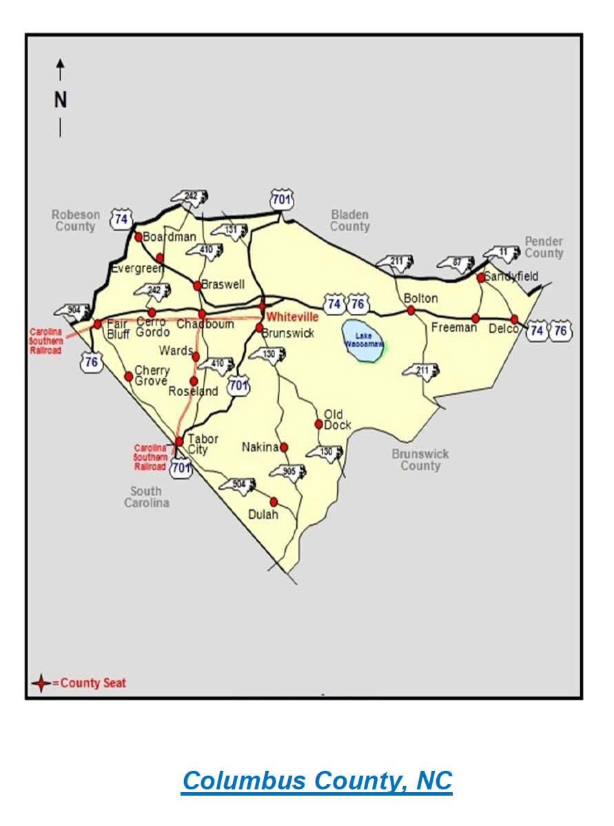

**DIRECTORY OF RESOURCES FOR COLUMBUS COUNTY**

Copies of Columbus County Resource Guides can be found by clicking on the links below.

<https://www.ncworks.gov/admin/gsipub/htmlarea/uploads/CRAG/Columbus_County.pdf>

<http://www2.columbusco.org/health/healthier/resourceguide.pdf>

[RESOURCE GUIDE](https://www.columbusco.org/sites/default/files/uploads/resources/resources.pdf)

[CountyDataProfile_Columbus_by_County_2024-0209.pdf](https://www.communityclinicalconnections.com/wp-content/themes/cccph/assets/downloads/Counties/CountyDataProfile_Columbus_by_County_2024-0209.pdf)

[Columbus County Quit-It Campaign | Columbus County, NC](https://www.columbusco.org/columbus-county-quit-it-campaign)

[Columbus County outlines opioid settlement spending strategy](https://www.wect.com/2023/01/31/columbus-county-outlines-opioid-settlement-spending-strategy/)

[Coalition hopes to coordinate efforts to combat opioid crisis in Columbus County  - Border Belt Independent](https://borderbelt.org/coalition-hopes-to-coordinate-efforts-to-combat-opioid-crisis-in-columbus-county/)

[CountyDataProfile_Columbus_by_County_2024-0209.pdf](https://www.communityclinicalconnections.com/wp-content/themes/cccph/assets/downloads/Counties/CountyDataProfile_Columbus_by_County_2024-0209.pdf)

[CountyDataProfile_Columbus_by_County_2024-0209.pdf](https://www.communityclinicalconnections.com/wp-content/themes/cccph/assets/downloads/Counties/CountyDataProfile_Columbus_by_County_2024-0209.pdf)

[2022-Opiod-Strategic-Plan-Columbus-County1.pdf](https://crhealthcare.org/wp-content/uploads/2022/10/2022-Opiod-Strategic-Plan-Columbus-County1.pdf)

1.